Step 1: Install Jenkins:
1.1. go to https://pkg.jenkins.io/ web page and download Jenkins rpm file using wget command .
# wget --no--check-certificate “https://pkg.jenkins.io./redhat-stable/jenkins-2.89.4-1.1.noarch.rpm”
1.2. install rpm file
# rpm -ivh jenkins-2.89.4-1.1.noarch.rpm
1.3. Check jenkins port no in below file
# vi /etc/sysconfig/jenkins

we have to set Admin password for first time. We can add users as well once jenkins is up an running.

Install backup plugin for backups.

Step 2: Create a job in Jenkins to build jar file using GIT repository:

Prerequisites:
1.GIT plug-in needs to be installed by going to Manage jenkins → Manage Plugins → Available. Search for GIT plug-in and click on check box and do install without restart.
2.Install “Hudson post build task” plugin as mentioned above.
3.Git and Maven software needs to be installed on machine where jenkins present.

2.1. Create a job by clicking on “New Item”
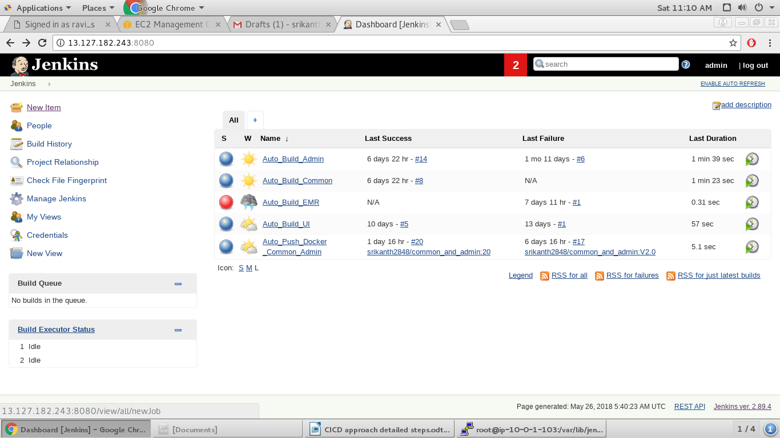

2.2. Choose free style project and give name to job.
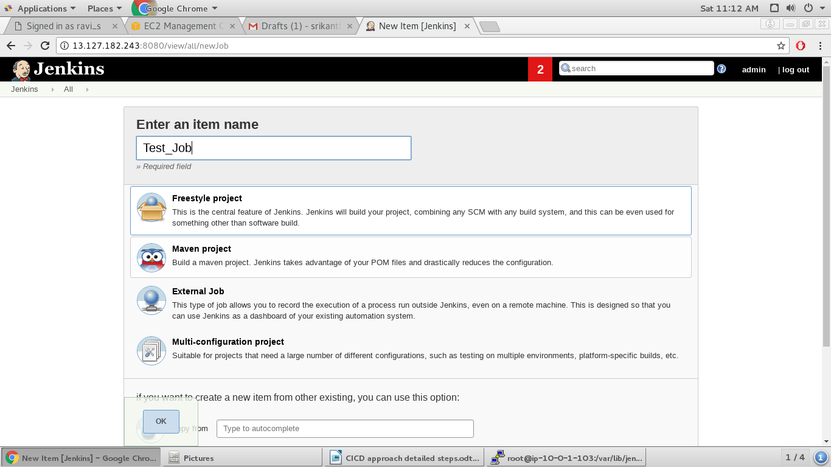
2.3. Click on Git under source code management, give repository name, Git credentials and branch name where repository present.
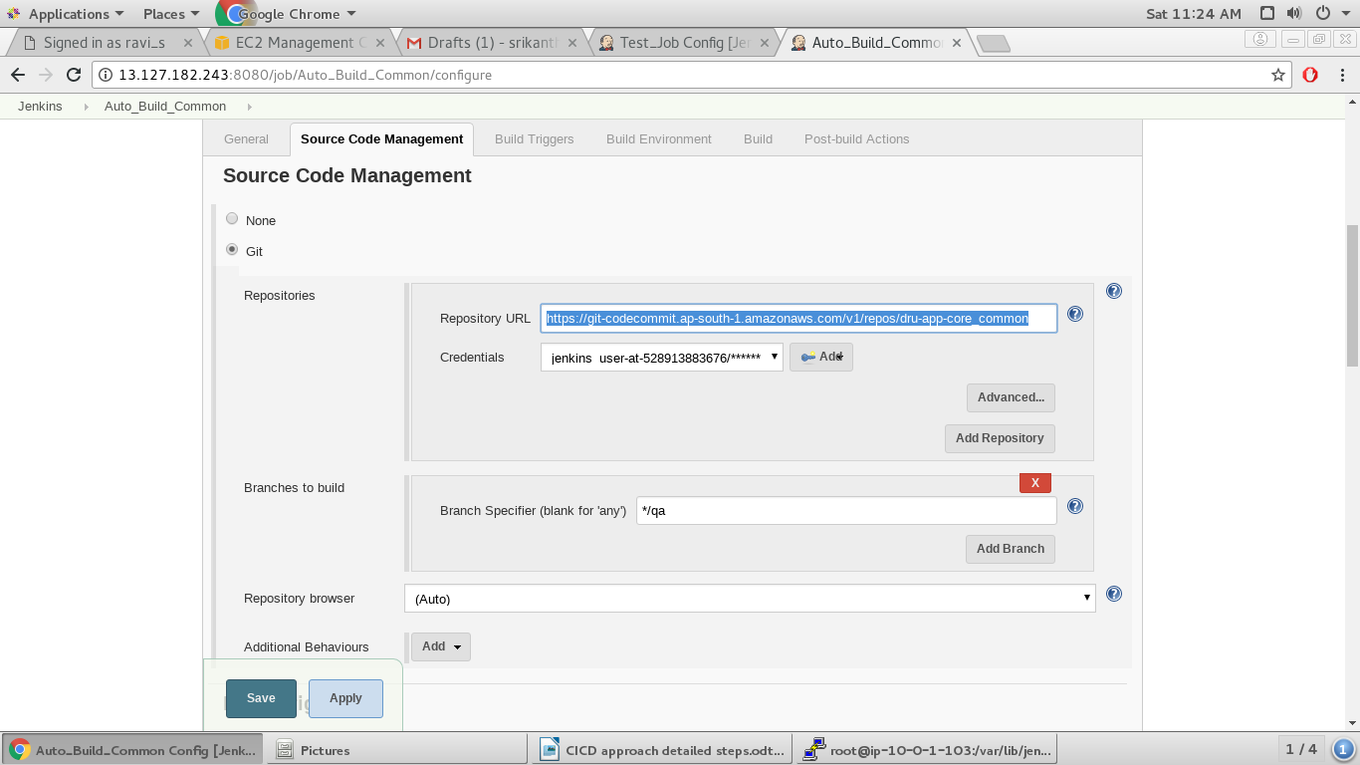

2.4. If we need to specify polling GIT repository at specific intervals of time we can specify it under Build triggers like below.
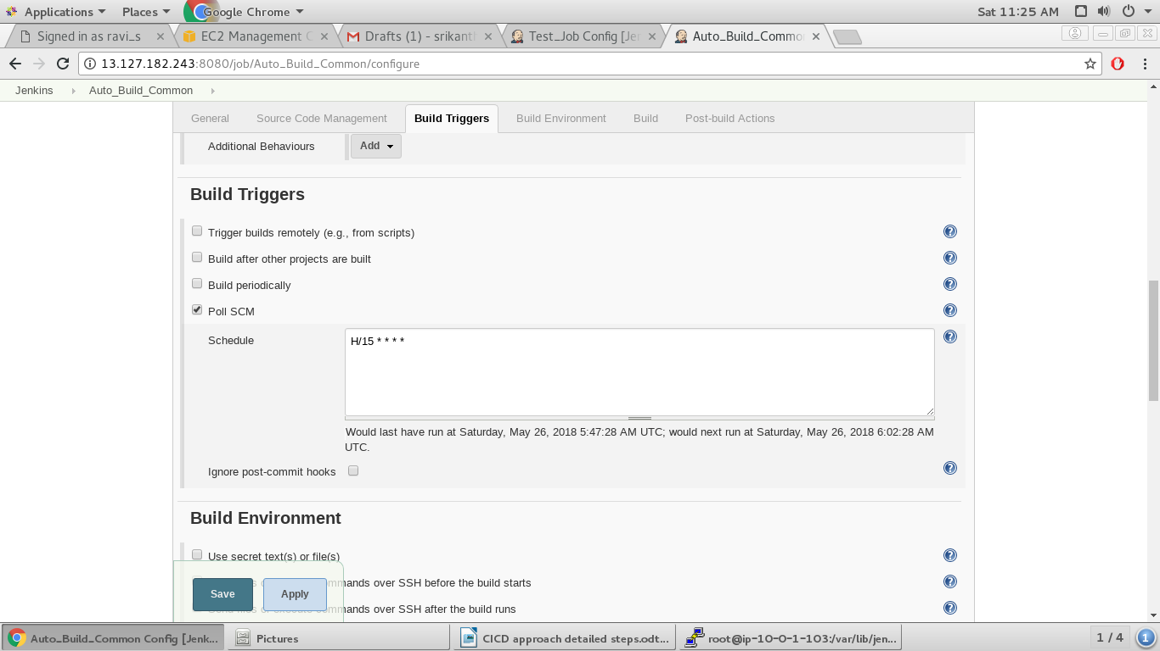
2.5. If job needs to be run after a specific job run completes use “Build after other projects are built” option and give predecessor job name.
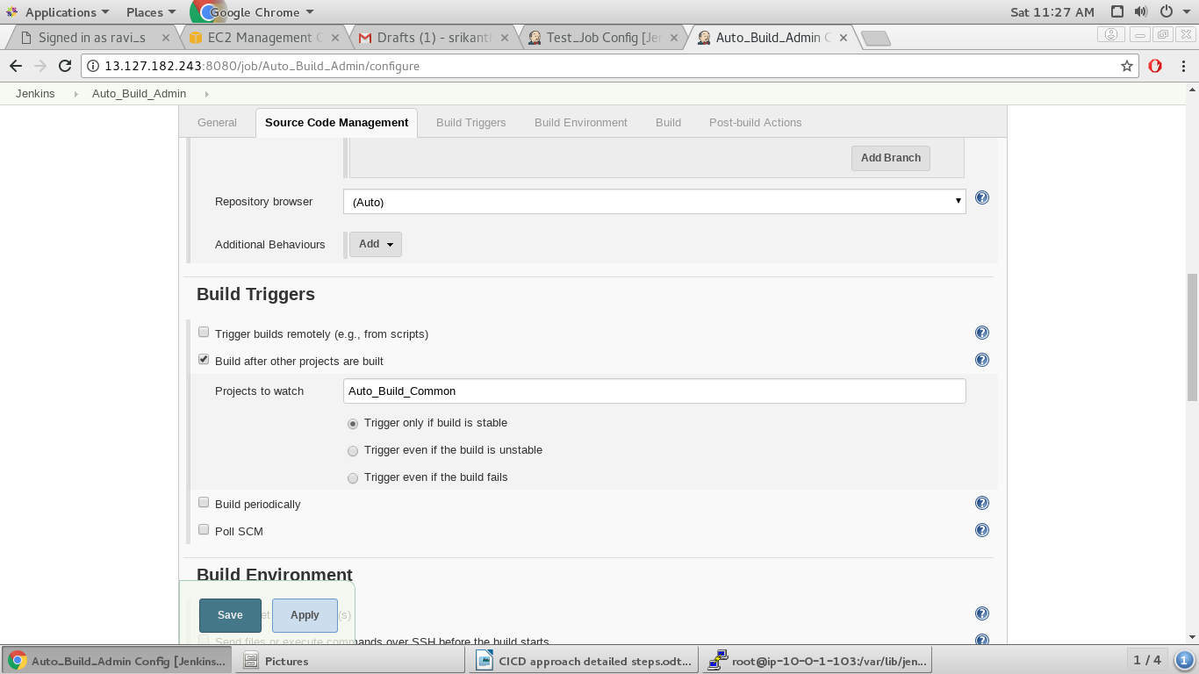

2.6. Under Build go to “Invoke top level Maven targets” and give “Clean site install” in gaols section.
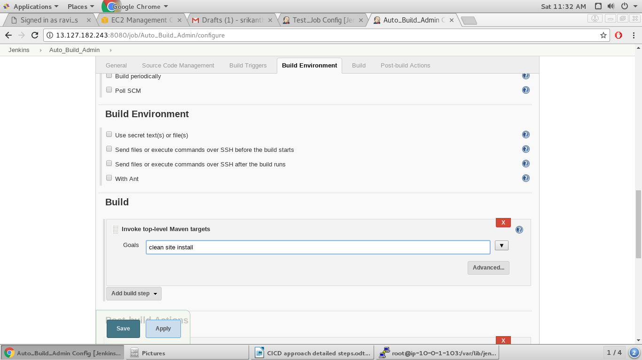
2.7. In Post-Build actions copy created jar file from from this job workspace to docker push job workspace. Later that jar file will be used to push docker image to docker hub(This is a separate job which will a successor job to present job)
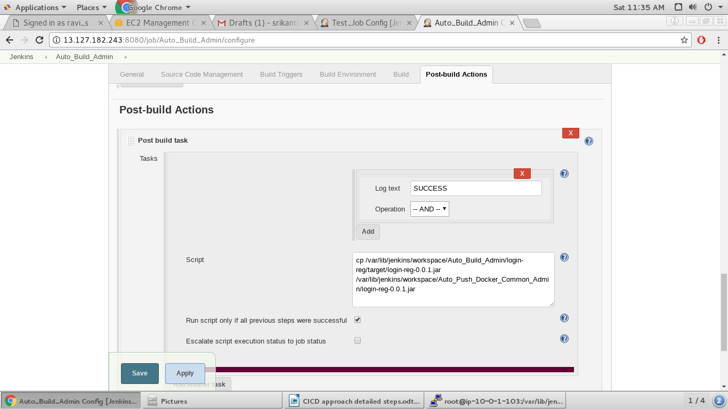
save the job and we can build the job once above all steps completed.
Step 3: Create a job in Jenkins to push a docker image to docker hub by using a jar file:

Prerequisites:
1.Plugin “Cloudbees docker build and publish” needs to be installed.

2.1. Give a name to job.
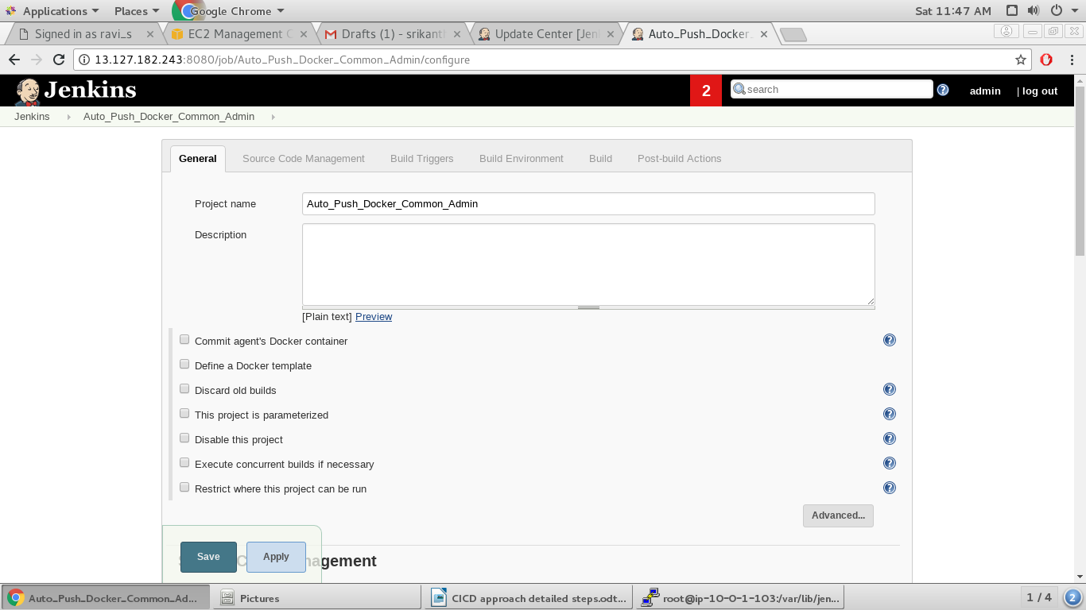
3.2. Give repository name of docker hub under repository name. Give tag number which indicates version number. Docker hub credentials needs to given for this job to push image to docker hub.
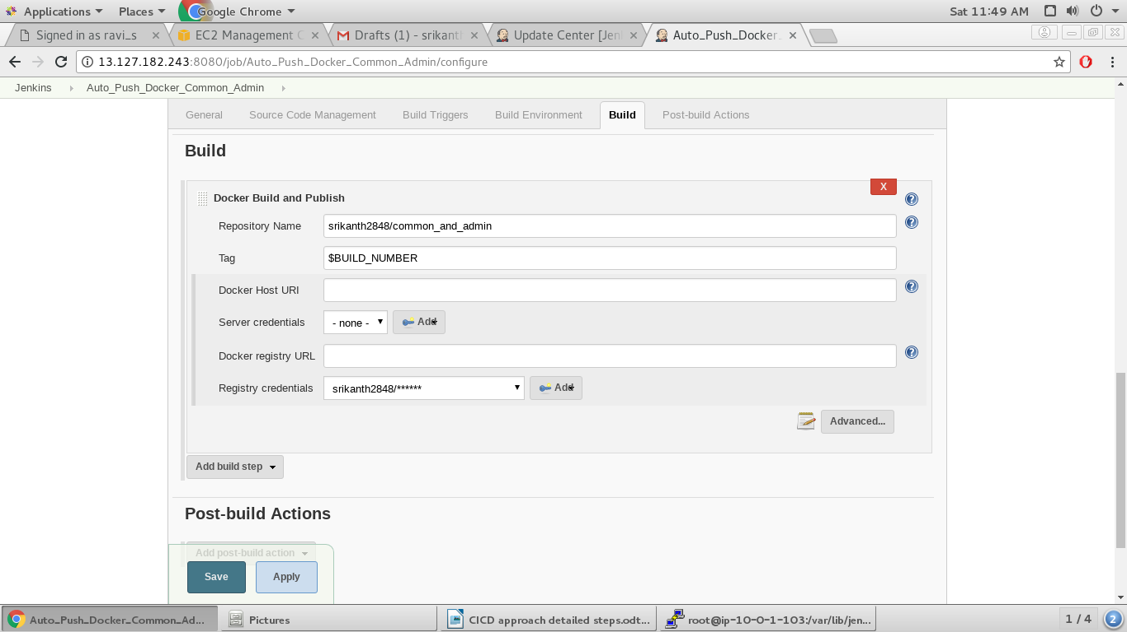
3.3. Docker file should be mentioned in Dockerfile path.

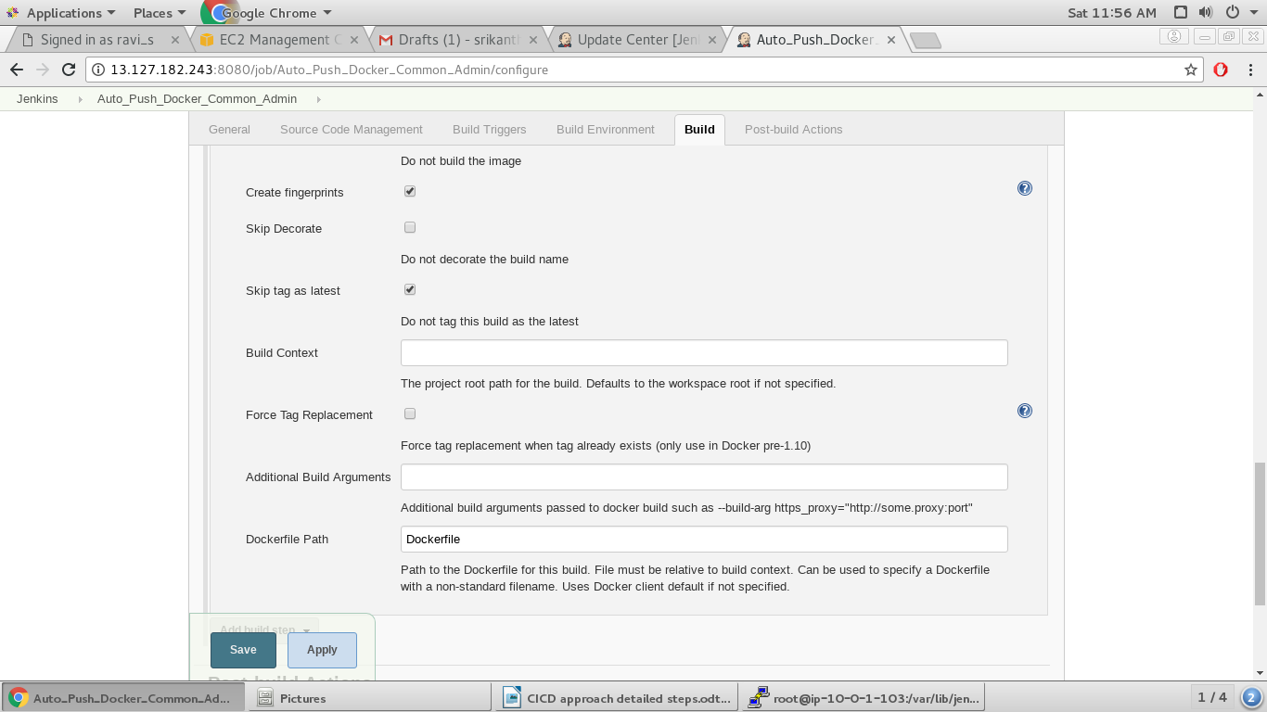
Dockerfile:

The docker file should be in present job's workspace folder with name as mentioned in above step.

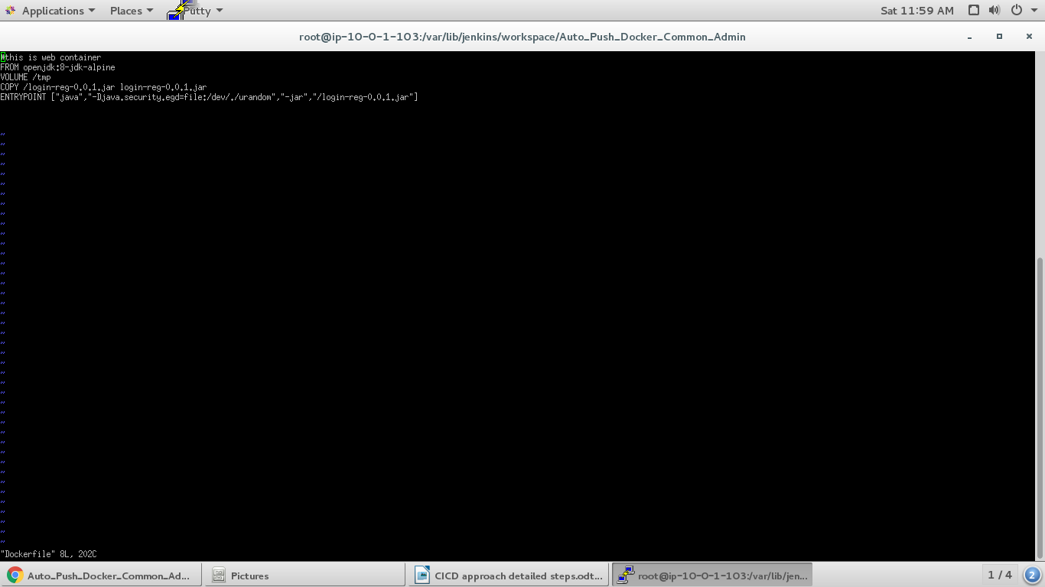

Once all above steps completes save the job and it is ready for Build.

Step 4: Create a job in Jenkins to build dist file using GIT repository(UI Build) and send it to Remote system:

Prerequisites:

1.Plugin “Publish Over SSH” needs to be installed.
2.NodeJs and Gulp software needs to be installed on jenkins machine.

NodeJs Installation:

cd ~
wget http://nodejs.org/dist/v0.10.3

Note: Your version number in the URL is likely to be different than the one above. Use the address you copied from the Node.js site rather than the specific URL provided in this guide.

sudo tar --strip-components 1 -xzvf node-v* -C /usr/local -->untar and install

link these 4 commnans to work proper.

sudo ln -s /usr/local/bin/node /usr/bin/node
sudo ln -s /usr/local/lib/node /usr/lib/node
sudo ln -s /usr/local/bin/npm /usr/bin/npm
sudo ln -s /usr/local/bin/node-waf /usr/bin/node-waf

node --version --> Check version

Gulp Installation:

npm install gulp -g

link below command to work proper.
sudo ln -s /usr/local/bin/gulp /usr/bin/gulp

check gulp’s version using:
gulp -v

4.1. Give a name to job

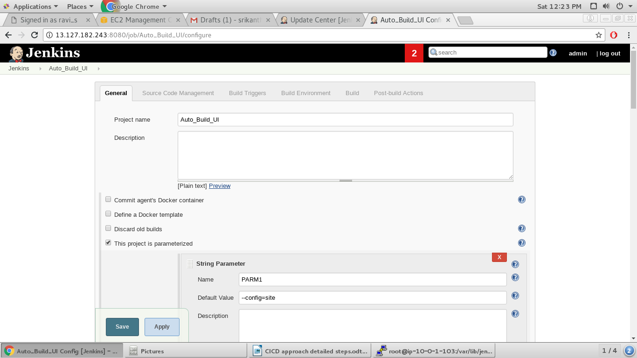
4.2. go to source code management and give git repository path, credentials and branch name where UI code present.

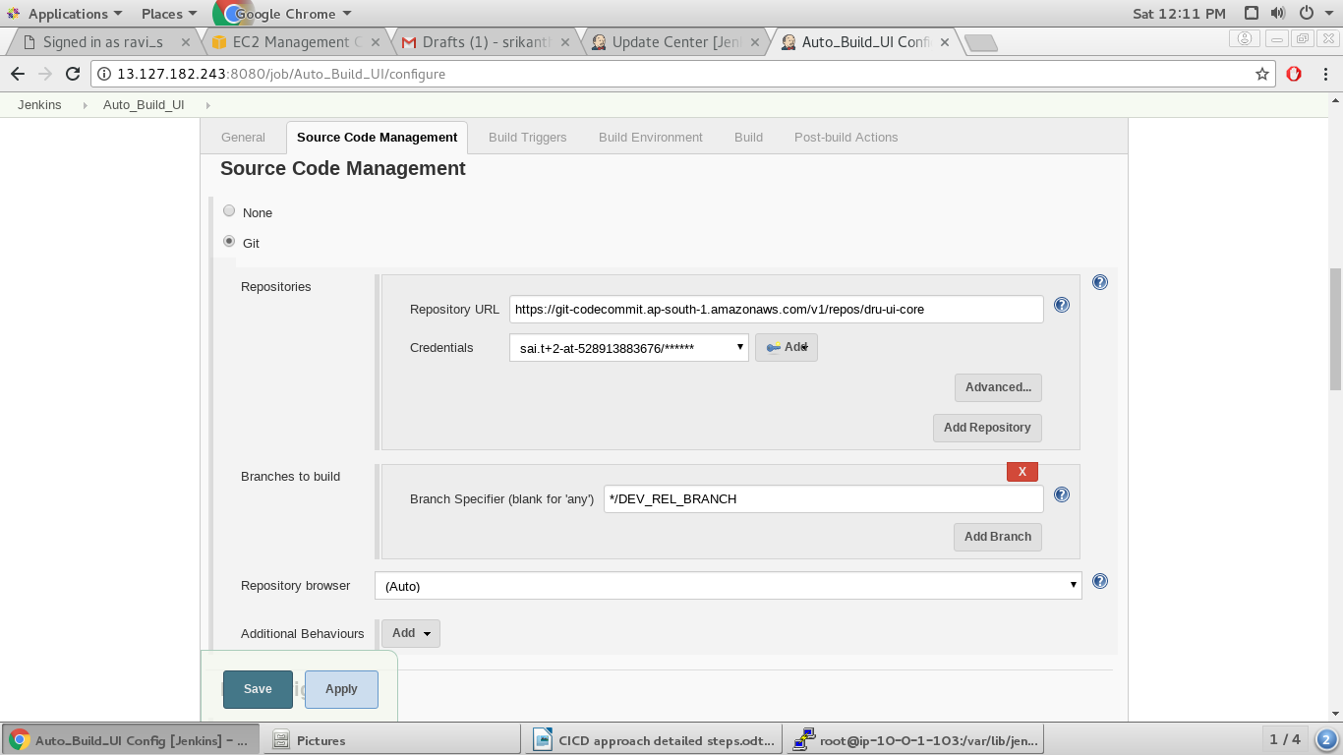

4.2. give below 2 commands in “Execute shell” section of Build
npm install
gulp package

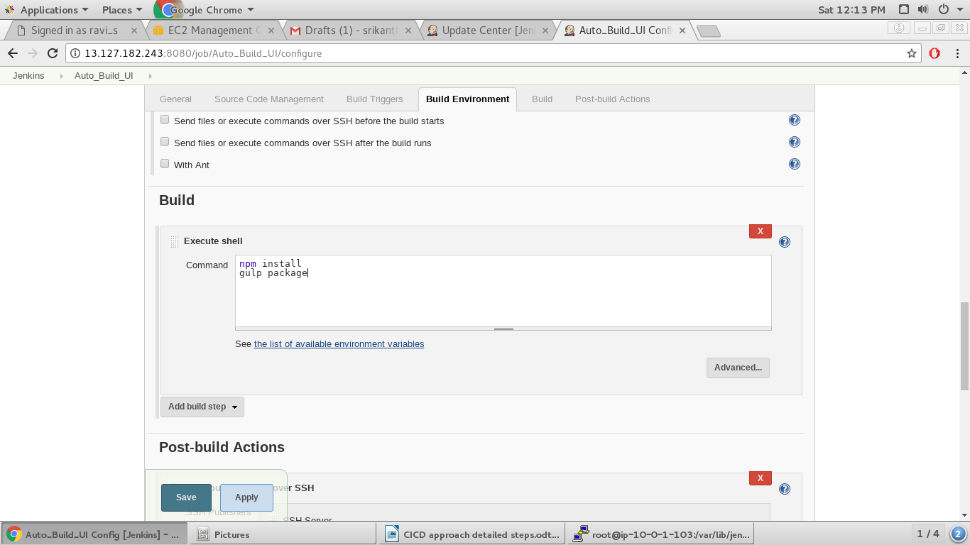

4.3. Under Post-Build actions use “Send Build artifacts over SSH”.

Name is target sever name which was defined in below step under configure system. Here, we need to mention source file from where to take artifacts and remote sever directory location to where artifacts are going to be copied.

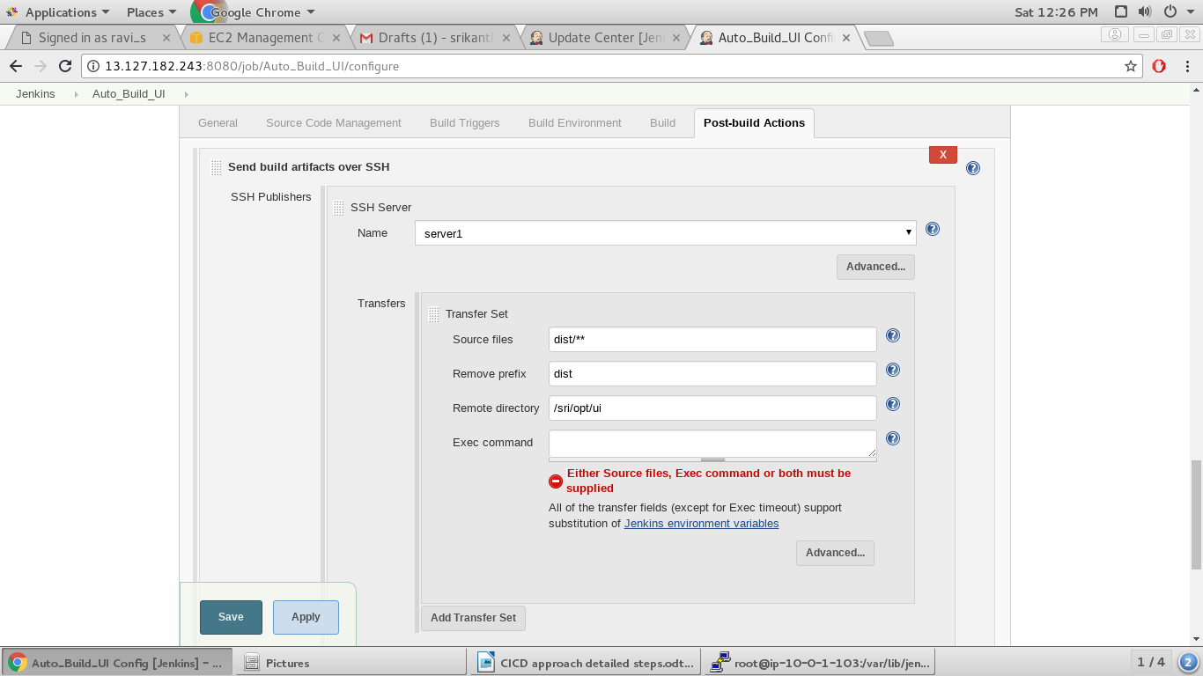

4.4. we need to give remote server details and jenkins machine SSH key location. We can generate SSH key using ssh-keygen command in jenkins machine and copy that to target machine using ssh-copy-id command.

→ ssh-keygen
→ ssh-copy-id centos@12.22.34.123

In “Path to key” place the location of private key which was copied above and present in jenkins machine
Name, user name and host name has to be provided.

Below setting should be done in Manage jenkins→ Configure system

we can test the connection here.

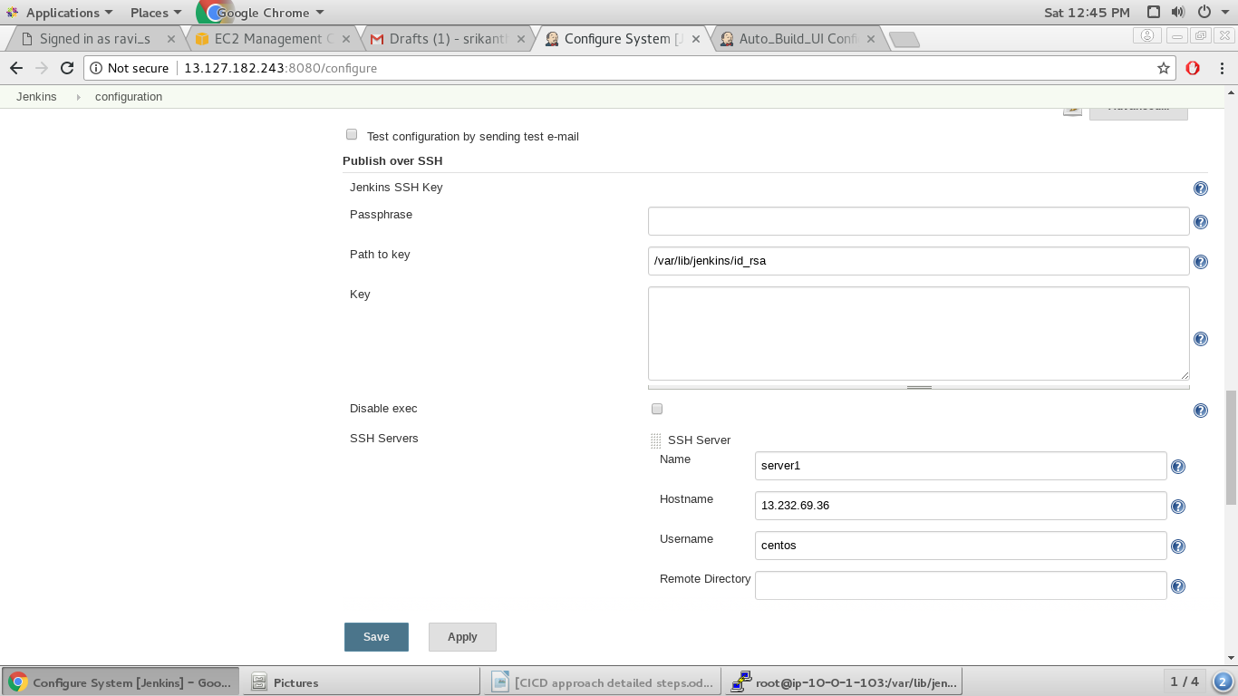

save the job and save above settings. Once above all steps done we are good to build the job.

